**Wildcards** (also referred to as meta characters) are symbols or special characters that represent other characters. You can use them with any command such as [ls command](https://www.tecmint.com/tag/linux-ls-command/) or **rm command** to list or remove files matching a given criteria, receptively.

These wildcards are interpreted by the shell and the results are returned to the command you run. There are three main wildcards in Linux:

* An asterisk (*) – matches one or more occurrences of any character, including no character.
* Question mark (?) – represents or matches a single occurrence of any character.
* Bracketed characters ([ ]) – matches any occurrence of character enclosed in the square brackets. It is possible to use different types of characters (alphanumeric characters): numbers, letters, other special characters etc.

You need to carefully choose which wildcard to use to match correct filenames: it is also possible to combine all of them in one operation as explained in the examples below.

**How to Match Filenames Using Wildcards in Linux**

For the purpose of this article, we will use following files to demonstrate each example.

createbackup.sh list.sh lspace.sh speaker.sh

listopen.sh lost.sh rename-files.sh topprocs.sh

**1.** This command matches all files with names starting with l (which is the prefix) and ending with one or more occurrences of any character.

$ ls -l l*

[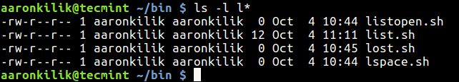](https://www.tecmint.com/wp-content/uploads/2017/10/List-Files-with-Character.png)List Files with Character

**2.** This example shows another use of * to copy all filenames prefixed with users-0 and ending with one or more occurrences of any character.

$ mkdir -p users-info

$ ls users-0*

$ mv -v users-0* users-info/ # Option **-v** flag enables verbose output

[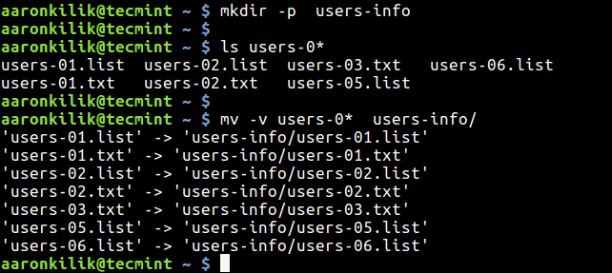](https://www.tecmint.com/wp-content/uploads/2017/10/List-and-Copy-All-Files.png)List and Copy All Files

**3.** The following command matches all files with names beginning with l followed by any single character and ending with st.sh (which is the suffix).

$ ls l?st.sh

[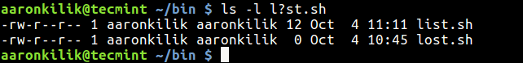](https://www.tecmint.com/wp-content/uploads/2017/10/Match-File-with-Character-Name.png)Match File with Character Name

**4.** The command below matches all files with names starting with l followed by any of the characters in the square bracket but ending with st.sh.

$ ls l[abdcio]st.sh

[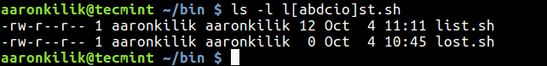](https://www.tecmint.com/wp-content/uploads/2017/10/Matching-Files-with-Names.png)Matching Files with Names

**How to Combine Wildcards to Match Filenames in Linux**

You can combine wildcards to build a complex filename matching criteria as described in the following examples.

**5.** This command will match all filenames prefixed with any two characters followed by st but ending with one or more occurrence of any character.

$ ls

$ ls ??st*

[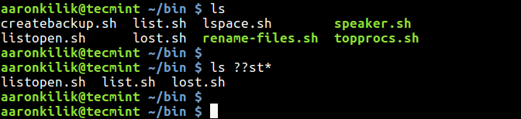](https://www.tecmint.com/wp-content/uploads/2017/10/Find-File-Names-with-Prefix.png)Match File Names with Prefix

**6.** This example matches filenames starting with any of these characters [clst] and ending with one or more occurrence of any character.

$ ls

$ ls [clst]*

[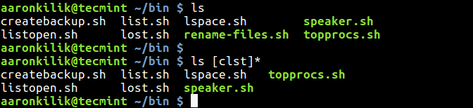](https://www.tecmint.com/wp-content/uploads/2017/10/Match-Files-with-Characters.png)Match Files with Characters

**7.** In this examples, only filenames starting with any of these characters [clst] followed by one of these [io] and then any single character, followed by a t and lastly, one or more occurrence of any character will be listed.

$ ls

$ ls [clst][io]?t*

[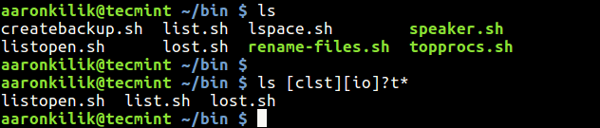](https://www.tecmint.com/wp-content/uploads/2017/10/List-Files-with-Multiple-Characters.png)List Files with Multiple Characters

**8.** Here, filenames prefixed with one or more occurrence of any character, followed by the letters tar and ending with one or more occurrence of any character will be removed.

$ ls

$ rm *tar*

$ ls

[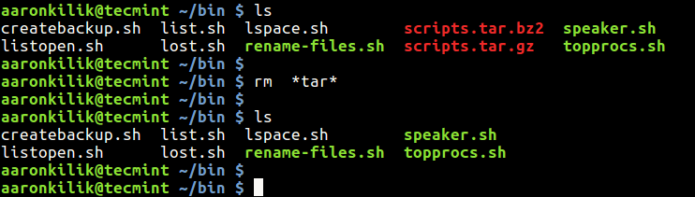](https://www.tecmint.com/wp-content/uploads/2017/10/Remove-Files-with-Letters.png)Remove Files with Character Letters

**How to Match Characters Set in Linux**

**9.** Now lets look at how to specify a set of characters. Consider the filenames below containing system users information.

$ ls

users-111.list users-1AA.list users-22A.list users-2aB.txt users-2ba.txt

users-111.txt users-1AA.txt users-22A.txt users-2AB.txt users-2bA.txt

users-11A.txt users-1AB.list users-2aA.txt users-2ba.list

users-12A.txt users-1AB.txt users-2AB.list users-2bA.list

This command will match all files whose name starts with users-i, followed by a number, a lower case letter or number, then a number and ends with one or more occurrences of any character.

$ ls users-[0-9][a-z0-9][0-9]*

The next command matches filenames beginning with users-i, followed by a number, a lower or upper case letter or number, then a number and ends with one or more occurrences of any character.

$ ls users-[0-9][a-zA-Z0-9][0-9]*

This command that follows will match all filenames beginning with users-i, followed by a number, a lower or upper case letter or number, then a lower or upper case letter and ends with one or more occurrences of any character.

$ ls users-[0-9][a-zA-Z0-9][a-zA-Z]*

[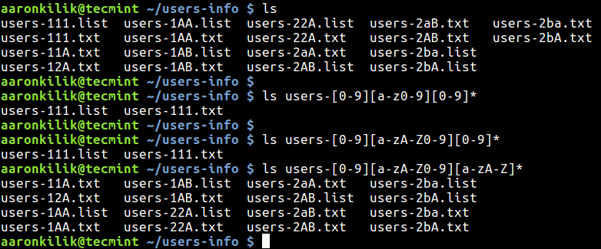](https://www.tecmint.com/wp-content/uploads/2017/10/Match-Characters-in-Filenames.png)Match Characters in Filenames

**How to Negate a Set of Characters in Linux**

**10.** You can as well negate a set of characters using the ! symbol. The following command lists all filenames starting with users-i, followed by a number, any valid file naming character apart from a number, then a lower or upper case letter and ends with one or more occurrences of any character.

$ ls users-[0-9][!0-9][a-zA-Z]*

That’s all for now! If you have tried out the above examples, you should now have a good understanding of how wildcards work to match filenames in Linux.